# DR – SQL Server Reporting Services

## Architecture

There are three SSRS instances for three environments:

* Adder (live)
* Devapps1 (development)
* DRsql2 (DR)

Each instance also has 2 supporting databases

* Adder
  + Server: adder
  + Database: reportserver
  + TempDB: reportservertempdb
* Devapps1
  + Server: UATMMA
  + Database: reportserver
  + TempDB: reportservertempdb
* DRsql2
  + Server: DRSQL2
  + Database: adder_reportserver

## DR Process

The adder databases are backed up and restored over the DR databases on DRSQL2 nightly.

All three instances are “always on”. However, when the restore process completes, the encrypted content stored on DrSql2 does not work against what is now a copy of the adder database. Attempting to access the DR reports site results in an error:

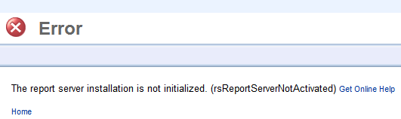

Currently, the only solution is to delete the encrypted content on londondrapps, which immediately fixes the site, with all the reports still intact; however, all connection string details stored within the data sources are lost and must be re-populated.

## Deleting Encrypted Content

Remote Desktop to londondrapps, select “Reporting Services Configuration Manager” from the start menu (or search for it)

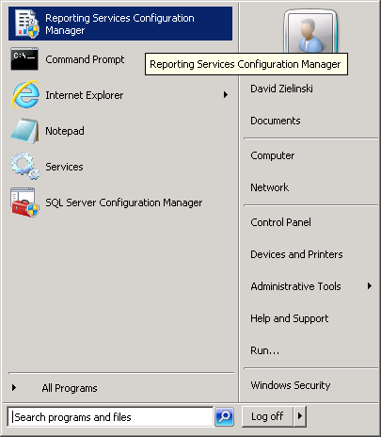

Click “Connect”

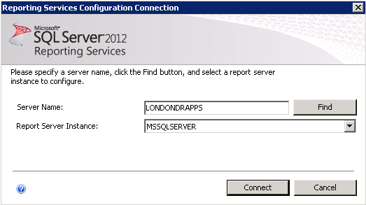

Select “Encryption Keys” from the left menu, and then hit “Delete” next to “Delete Encrypted Content”

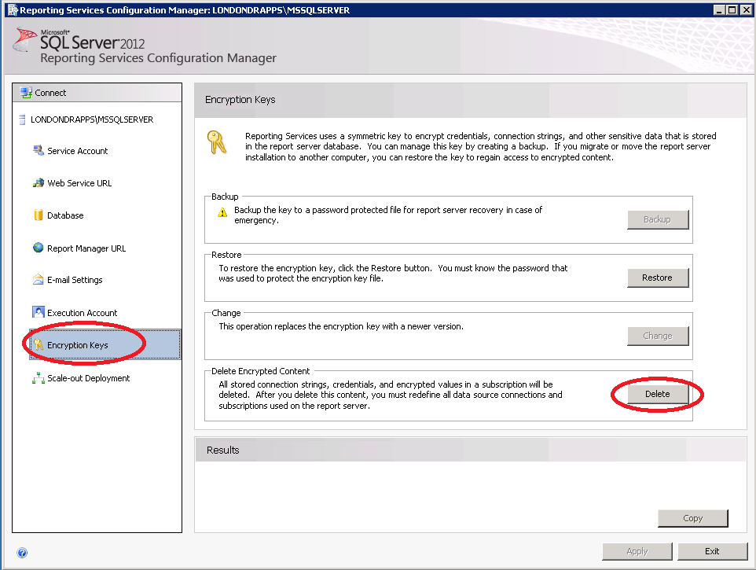

Hit “Yes”

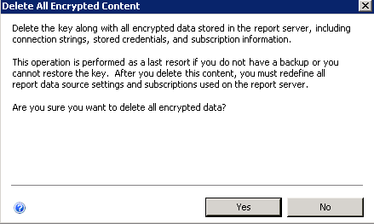

At this point the DR SSRS reports site will be fixed, but no data sources will work.

## Fixing Connection String Details

Future plan is to have a script using rs.exe to do this automatically. Currently the process is manual.

Navigate to <http://DRsql2/reports>

Click “Data Sources”

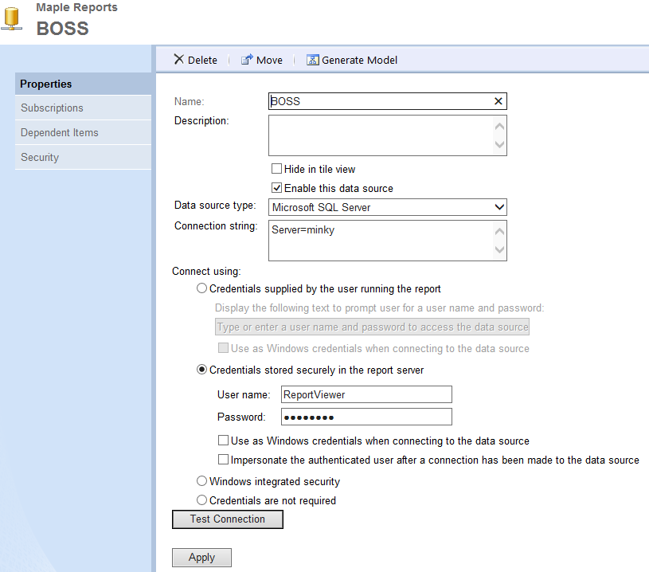

For each datasource, click the datasource and fill in the details as follows, but **replace servers with server=drsql2**

|  |  |  |  |
| --- | --- | --- | --- |
| Name | Connection String | User name | User as Windows… |
| BOSS | Server=minky | ReportViewer | No |
| Boss2000 | Server=Minky;database=BOSS2000 | Bossviewer | No |
| *2 BossDev | Data Source=CAT\DEV;Initial Catalog=boss2000 | ReportViewer | No |
| BossTest | Data Source=uatminky;Initial Catalog=boss2000 | ReportViewer | No |
| *1 BossUITest | Blank |  |  |
| DataSource1 | Server=minky;Database=Boss2000; | reportviewer | No |
| DEVBOSS | server = devminky | Reportviewer | No |
| KondorUK | server=mma1;database=KondorUK | ReportViewer | No |
| *1 MinkyOld | Blank |  |  |
| MMA | Data Source=MMA1;Initial Catalog=fmop2 | reportviewer | No |
| Reconciliation | Server=minky;Database=Reconciliation; | ReportViewer | No |
| Settlements | Server=Minky;database=Settlements | Bossviewer | No |
| *2 Sharepoint | server=cougar\officeservers;database=mpuk_views | SPViewer | No |
| *3 UATBOSS | server = uatminky | [local account] | Yes |
|  |  |  |  |
| *4 Tfs2010OlapReportDS | Data Source=adder;Initial Catalog=Tfs_Analysis | MPUK\SQLAdmin | Yes |
| *4 Tfs2010ReportDS | Data Source=skunk;Initial Catalog=Tfs_Warehouse | MPUK\SQLAdmin | Yes |
|  |  |  |  |
| *5 TestBoss2000 | Server=Minky;Database=Admin | ReportViewer |  |
|  |  |  |  |

*1 – Credentials supplied by the user running the report

*2 – Server old, data source presumed unused

*3 – probably shouldn’t be configured using a local account, but currently is for testing purposes

*4 – these data sources are located on the main page (Home), not within the Data Sources folder

*5 – this data source is located in Tests, not within the Data Sources folder

After inputting each data source, you can click “Test Connection” to confirm it works correctly.

Then hit “Apply” to save.

At this point DR SSRS is set up and working .